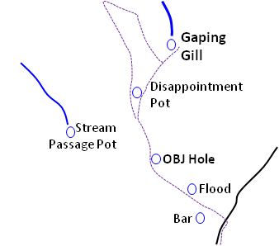
OBJ Hole: Brief Introduction, Description & Trip Report
N
In 1949 members of the BSA explored a shakehole between Gaping Gill and Flood Entrance Pot, naming it after a beer brewed by Dutton's brewery in Blackburn (the initials stand for Oh Be Joyful!). The shakehole led, after a short climb down, to a false drop over which the first pitch was reached. This led down to either a too tight rift or a 20 odd metre drop to a shingle floor with no way on. At this time, the map of the Eastern flank of Ingleborough, at least in terms of cave entrances, was very different. Along with the two known routes into the main chamber; Direct Route and Jib Tunnel, Flood Entrance Pot (so named as it allowed entry to the system when Fell Beck was in full flow), was also well known having been discovered in 1909. Rat Hole and Disappointment Pot followed but that was it, 5 entrances. Then in 1949, both Stream Passage Pot and Bar Pot were discovered, not only new entrances but new areas too. Perhaps the draw of new areas pushed OBJ Hole to the back of the mind, where it stayed for 60 years, despite having a definite vocal link with Flood Entrance Pot near Cigarette Chamber.
Six decades later in 2010 at the Bradford Pothole Club winch meet Gerald Benn and Fred Rattray worked the too tight rift and connected OBJ Hole to the Gaping Gill system, creating its 21st entrance. You can read about it in the BPC Bulletin 7 and it’s a great read with maypoles, fluorescein and incidents galore. Despite my fear of a too tight connection, the Bradford did a good job of making it human size and although chossy in places, it adds variety to a GG trip, a difficult extra bit compared with Bar Pot, or Wade’s Entrance.
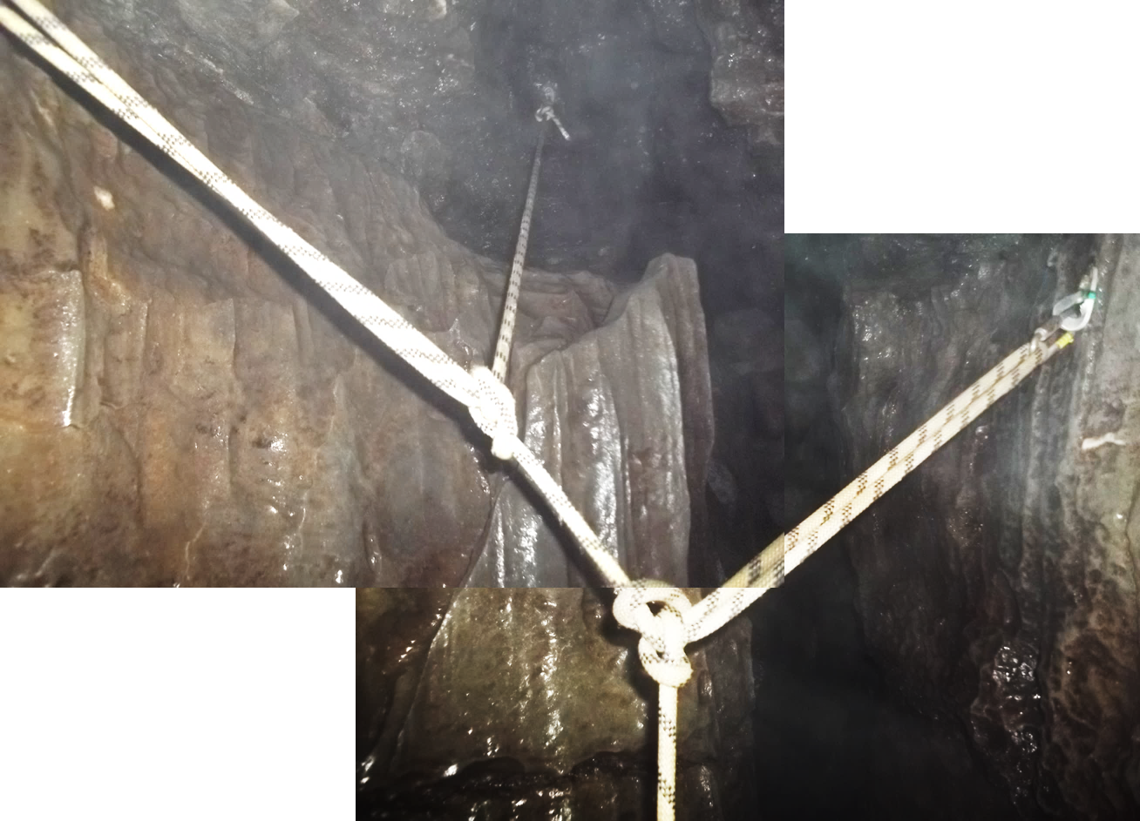
The cave is equipped with 8mm bolts which are solid but not always obvious. From the surface the climb down the shakehole is no bother, it does narrow, forcing a wriggle at floor level past drink bottles and discarded gubbins dropped into the inviting “poubelle” by the walkers path. It gets surprisingly drippy, drips that seem to home in on the gap between suit neck and helmet. On the right is the backup for the first pitch, just as you pass over a small inlet running into the exaggerated false drop mentioned in NC2.
The pitch head is supplied with three spits, the first is 2m before the main hang. I don’t intend to preach from my chair, but being low hints at axial load rather than shear, so I shared the force (Ian “Choc Ice” Ball) over all three anchors.
The traverse line from the first bolt ended up rather low so be careful, it’s not slippery but there is a long enough drop to require a very loud “ouch!”

OBJ Hole First Pitch

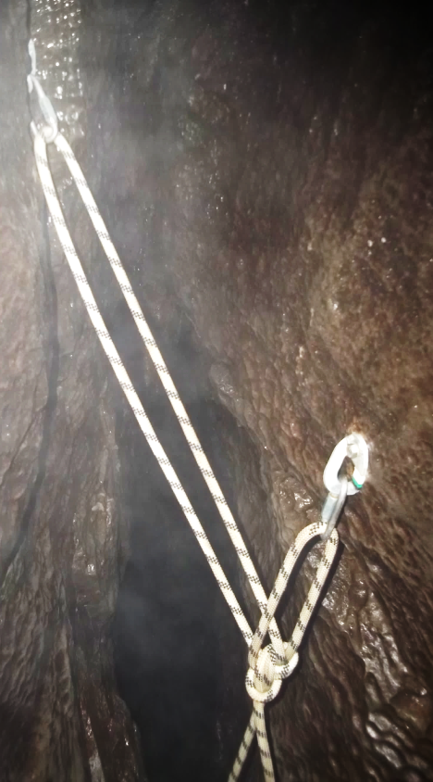
The first pitch drops 7m down a rift to a rebelay where the rift narrows in creating a false floor and a 2nd, narrower section of the rift that drops a further 7m to the floor. One bolt is higher than the other and took a while to spot. At first I didn’t spot it so rigged without it. Over 6m of rope above to the previous bolts so it’s ok as a single rebelay but requires delicate climbing to avoid rub.
OBJ Hole
First Pitch
Rebelay
As the bolts are offset, I used a BotB due to the ease of adjustment. Squidge through into the 7m drop below, passing a rift leading ahead before a few metres more lands on the floor. A waist height spit in the wall acts as backup for the 2nd pitch named ‘Killer’ by the Bradford crew. The rift passed on the way down, at the top of a diggers’ dry stone wall, leads to the mysterious 18m ladder pitch shown on the LUSS 1980 Bar Pot and Flood survey. It shows the pitch in a chimney ending at a gravel floor with near vertical sides, but interestingly the depth is greater than the corresponding passages in Flood Entrance Pot. Any connection would not be to Flood so where does it go? Is it half filled with gravel? There are no known passages in the area, or at the known depth, it is a mystery which could well be waiting a while. The rift to the head of the 18m is a little tight, too tight for srt kits and straight over the 18m drop so no kitting up the other side and very little to belay a ladder to. There is a spit placed there to help, not that I found it mind, possibly as I didn’t look for it. I imagine the BPC hold first refusal over digging rights, but the enigma of that shaft is plain to see on the LUSS survey, anyone fancy braving the rift is welcome to give it a go
OBJ Hole First Pitch Rebelay
(before adjustment)
.

